Abstract
This project presents a Patient Record Management System developed for the PROG211 Object-Oriented Programming 1 assignment. The project is based in the Health domain and demonstrates fundamental object-oriented programming concepts using Python. The system allows users to register patients, display patient records, search for patients, and show the total number of registered patients. The implementation uses two main classes, Patients and Doctor, with attributes and methods that represent real-world entities and their behavior. Lists are used to store multiple objects, while instance methods and a class method demonstrate different forms of object-oriented behavior. The project also considers Digital Public Goods principles by using reusable Python code, a modular structure, and fictional sample records instead of real sensitive patient information. Testing was performed through the program’s menu and covered the major functions and instructions. The final system is a simple command-line prototype that demonstrates how OOP concepts can be applied to a basic health-record workflow.

Introduction
Healthcare services depend on accurate handling of patient information. Even a small clinic or training environment needs a structured way to register patients, maintain basic records, and associate patients with doctors. This project addresses that basic need through a small command-line Patient Record Management System.
The project was selected from the Health domain allowed by the assignment. It is an educational prototype rather than a production medical system. Fictional sample information is used for demonstrations. The assignment requires at least two relevant classes, attributes and methods, object creation and interaction, a data structure for multiple objects, functions for adding and displaying records, an instance method, and a class method. The system was designed specifically to demonstrate these requirements.
The two main classes are Patient and Doctor. Patient stores basic patient information and an optional assigned doctor. Doctor stores doctor information and a list of assigned patient objects. The main menu connects the classes and functions so the user can operate the system without editing source code directly.

Literature Review`
Object-oriented programming organizes software around objects that combine data and behavior. A class provides a blueprint from which objects can be created. In this project, Patient and Doctor are classes, while individual patients and doctors created during execution are objects. This approach is suitable because patients and doctors are naturally represented as entities with properties and operations.
Python supports object-oriented programming through classes, constructors, instance attributes, instance methods, class variables, and class methods. The __init__ constructor initializes an object. Instance methods receive self and operate on individual objects. The show_total_patients methods use @classmethod and receives cls s that it can work with class-level information.
Lists provide a simple data structure for holding multiple Patient and Doctor objects. The program can add objects to these lists and iterate through them for searching and display. The Doctor class also maintains a list of Patient objects, which demonstrates an object relationship.
The assignment also emphasizes Digital Public Goods principles, including openness and reuse, inclusion and accessibility, privacy protection, and modularity. This project supports these ideas through understandable Python source code, a modular class/function structure, and fictional records for demonstrations.

Methodology
Problem Analysis
The problem was analyzed as a small record-management task. The required operations were identified as registering patients, displaying records, searching for a patient, updating a patient’s condition, registering doctors, displaying doctors, assigning doctors to patients, displaying a doctor’s patients, and counting registered patients. The analysis also considered the assignment marking areas for classes, data structures, methods, Digital Public Goods, and documentation.
Program Design
The Patient class contains Patient_id, name, age, gender, condition, blood_group, and doctor. It also contains the class variable total_patients. The Doctor class contain doctor_id, name, specialization, department, and patients. The main patient and doctor lists are created in main_menu and passed to the record-management functions.
The application uses a menu-drive design. Each menu option calls a separate function, making the program easier to understand and maintain. Patient and Doctor objects interacts when a doctor is assigned to a patient. The patient stores the doctor object and the doctor stores the patient object in its patients list.
Coding
The system was coded in Python using Pycharm. The implementation is kept in one source file named patient-record-system.py. Comments divide the code into logical sections. Validation is included for patient age, duplicate patient IDs, duplicate doctor IDs, missing doctor and invalid menu choices. The assignment function also prevents duplicate patient entries and removes the old doctor relationship when a patient is reassigned.
Testing
Testing was performed by running the program through its menu with fictional sample records. Tests covered successful and unsuccessful searches, record update, patient and doctor registration, doctor assignment, to total patient counting, and display functions. Invalid age input and invalid menu choices were also considered.
Evaluation
The completed system was evaluated against the assignment requirements. It contains two relevant classes, multiple attributes and methods, object creation, object interaction, list-based storage, functions for adding and displaying records, an instance method, and a class method. The use of fictional data also supports the privacy requirement.

Results
The completed program provides a working command-line patient record application. Users can register patients and doctors and retrieve their information through menu options. Searching by patient ID returns a matching patient, while updating a record changes the stored medical condition. A doctor can be assigned to a patient, and the relationship can then be viewed through the patient record and the doctor’s assigned-patient display.
The class method reports the number of Patient objects created during the current session. The program also handles common input problems such as duplicate IDs, invalid age values, unknow doctor IDs, and invalid menu choices.

Program Evaluation and Key Findings
Functional Evaluation
The system performs the main operations defined during design. Patient registration creates a Patient object and stores it in the patient list. Doctor registration creates a Doctor object and stores it in the doctor list. Search and display functions iterate through these lists. Updating a record calls an instance method on the selected Patient object. Doctor assignment demonstrates direct interaction between Patient and Doctor objects.
Usability Evaluation
The interface is text-based numbered menu. Each operation prompts the user for the information required. Clear messages provide feedback after actions. Although it is not graphical, the interface is straightforward for an introductory programming project and does not require external libraries.
Security Evaluation
The system is an educational prototype and does not implement production-level authentication, encryption, audit trails, or access control. Only fictional/sample patient data should be used during demonstrations. The program does not save records permanently, so data entered during a session is lost when the program exist.
Efficiency and Performance
For the small number of records expected in an introductory assignment, the program is lightweight and performs efficiently. Searching is done by iterating through lists, which is suitable for a small dataset. A database or indexed structure would be more appropriate for a large healthcare system.
Key Findings
The two-class design demonstrate core object-oriented programming concepts.
Patient and Doctor object interact through doctor assignment.
List provide simple storage for multiple objects.
The class method provides class-level patient counting.
Input validation improves reliability for common user errors.
Fictional records support privacy during demonstrations.
The command-line interface is appropriate for the assignment scope.
Report
The project addresses the need for a simple way to manage basic patient and doctor records in small educational health setting. Manual handing can make searching and updating records inconvenient. The program provides a structured alternative by representing patients and doctors as objects and managing them through a menu.
Design and Implementation
The Patient class is responsible for patient information and patient-specific operations. The Doctor class is responsible for doctor information and the list of patients assigned to the doctor. Functions outside the classes handle menu-level activities such as adding, searching, updating, displaying, and assigning records. This separation keeps
Code Implementation
Each class uses a constructor to initialize attributes. Patient contains display_info, update_recored, assign_doctor, and show_total_patients. The first three are instance methods, while show_total_patients is a class methods. Doctor contains display_info, add_patient, and display_patients. The main_menu function controls the overall program flow.
Testing
Testing used fictional sample data such as Patient P001 John Kamara, Patient P002 Aminata Sesay, Doctor D001 Dr. Mohamed Conteh, Doctor D002 Dr. Fatmata Koroma. The tests confirmed that records could be created, displayed, searched, updated, and connected.
Test Action | Expected Result | Status
T01 Add patient | Patient stored and success message displayed | Pass
T02 Display patients | Stored patients displayed | Pass
T03 Search patient | Matching patients displayed | Pass
T04 Search unknown ID | Patient not found message | Pass
T05 Update patient | Condition changed | Pass
T06 Add doctor | Doctor stored | Pass
T07 Assign doctor | Patient-doctor relationship created | Pass
T08 Doctor’s patients | Assigned patient display | Pass
T09 Total patients | Class method display total | Pass
T10 Invalid input | Validation/error message | Pass

Result
The test results show that the implemented functions work together as one application. The program maintains records during a session and provides feedback after major actions. The Patient and Doctor relationship is visible from both sides of the assignment.

Discussion
Problem-Solving Capability
The program provides a basic solution to the identified record-management problem. It replaces an unstructured approach with classes, lists, and menu functions. The design is small enough for an OOP1 assignment while still showing how a real-world problem can be translated into software objects and operations.
Usability and User Interface
The interface in intentionally simple. Users select numbered options and provide information through prompts. Clear menus and feedback messages make the system easy to operate for a beginner. A graphical interface could improve the experience in a future version.
Accuracy and Reliability
Reliability is supported by duplicate-ID checks, age validation, checks for missing patients and doctors, and prevention of duplicate patient entries. The system is accurate for the operations it implements, but the records are temporary because there is no permanent database.
Efficiency
The program has low overhead and runs without external packages. For a small number of records, list-based searches are adequate. As the number of records increases, a dictionary indexed by ID or a database would provide a more scalable solution.
Potential Improvements
Add permanent storage using SQLite or another database.
Add authentication and role-based access for a real deployment.
Add storage validation for all input fields.
Provide a graphical user interface.
Add deletion and more complete recode-editing features.
Add timestamps and audit logs.
Encrypt sensitive information in a production environment.
Add automated unite tests.

Conclusion
The Patient Record Management System successfully demonstrates object-oriented programming concepts applied to a simple health-related problem. The project uses Patient and Doctor classes, attributes, objects, instance methods, a class method, lists, and object interaction. The menu provides the major record-management functions defined during design. Testing showed that the main operations performed as expected. The project also supports Digital Public Goods considerations through reusable code, modular structure, and fictional demonstration data. Although it is not intended for production healthcare use, the system provides a suitable foundation for demonstrating OOP1 concepts and can be extended with permanent storage, authentication, improved validation, and graphical interface.

Appendices
Appendix A Source Code Files
The main source-code file is patient_record_system.py. It contains the Patient and Doctor classes, record-management functions, the main menu, validation logic, and the program entry point. The complete source code is included as a separate Python file accompanying this report.

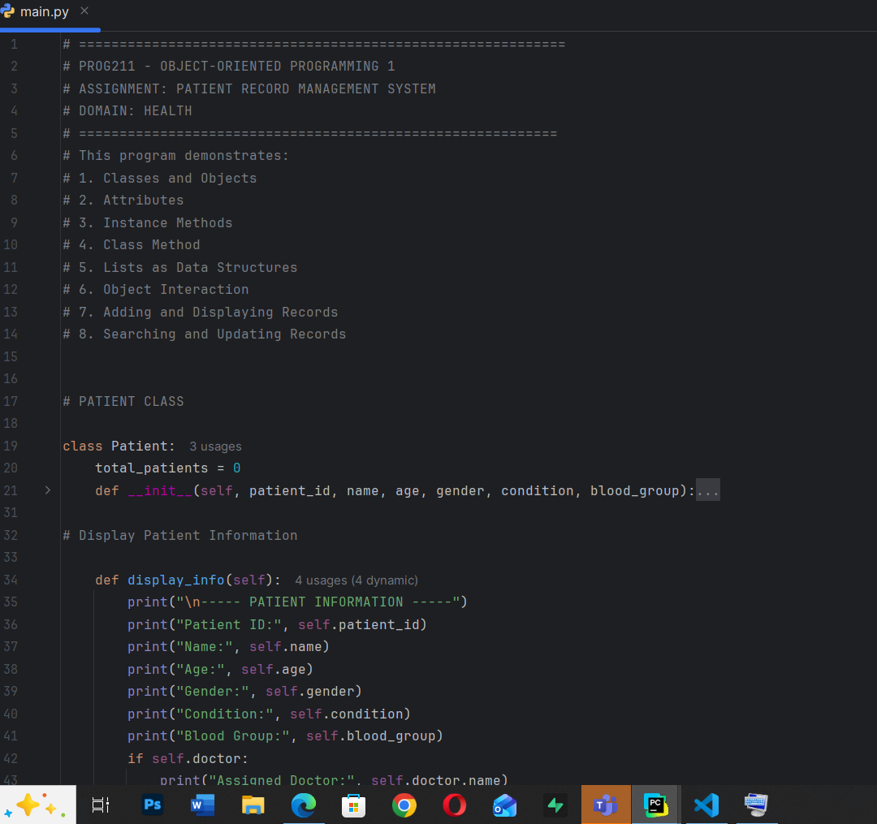

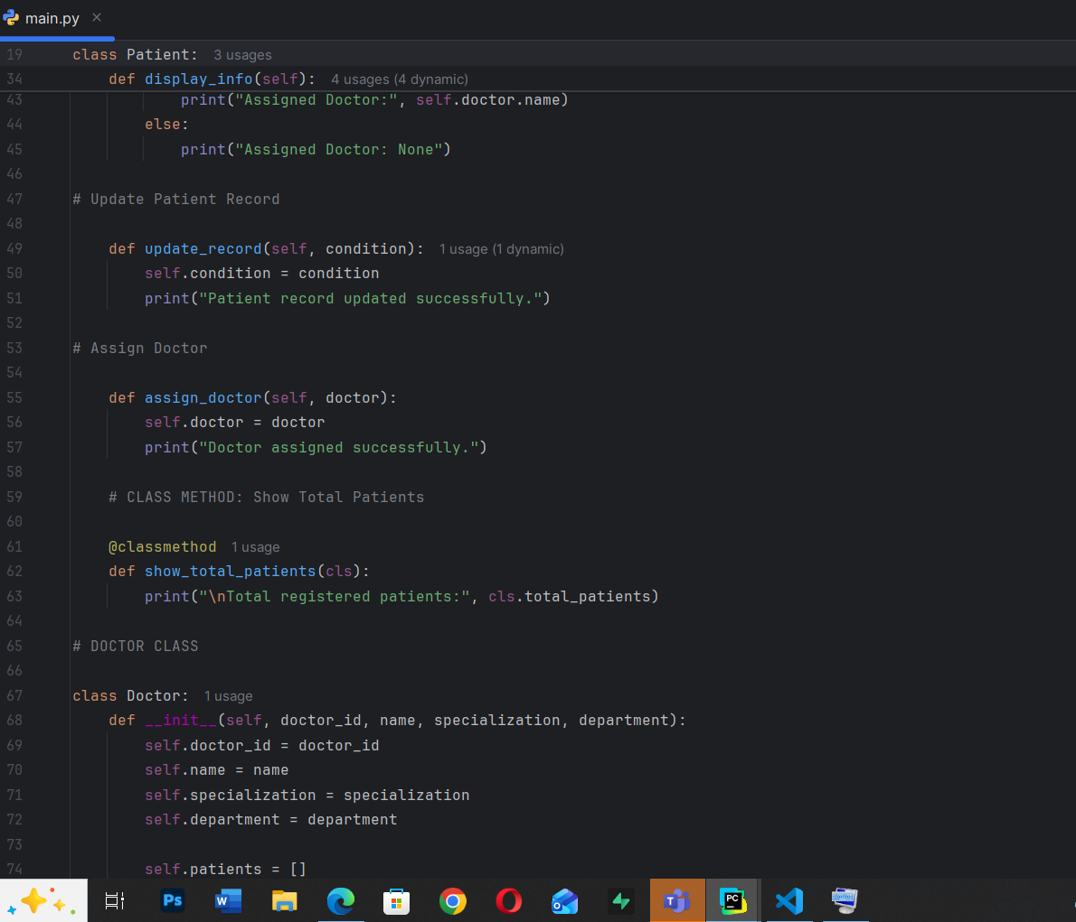

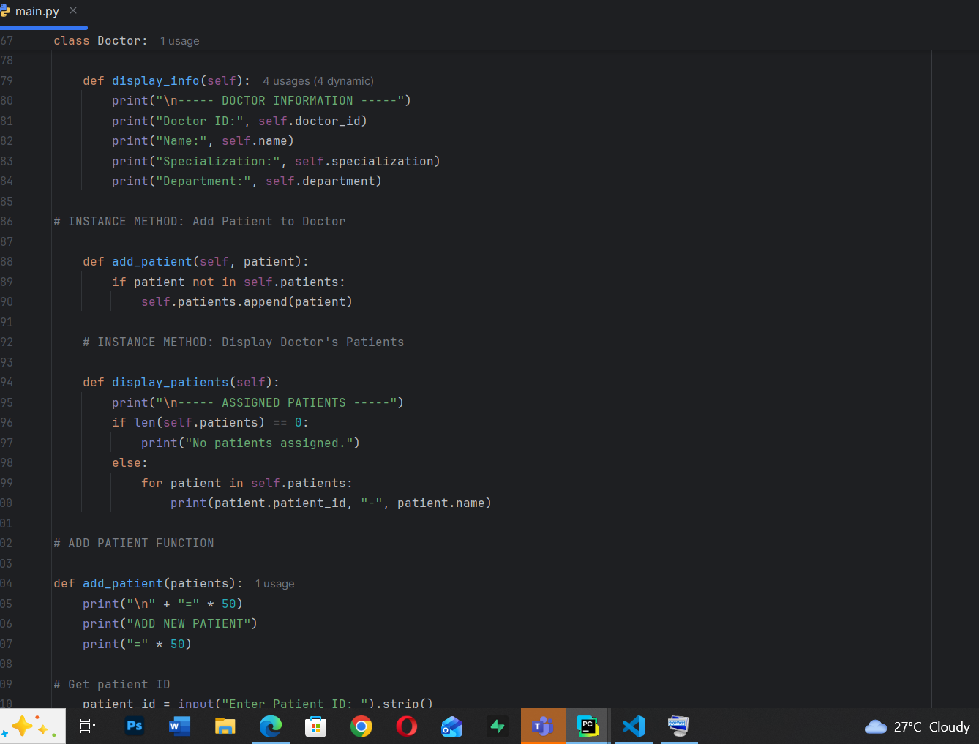

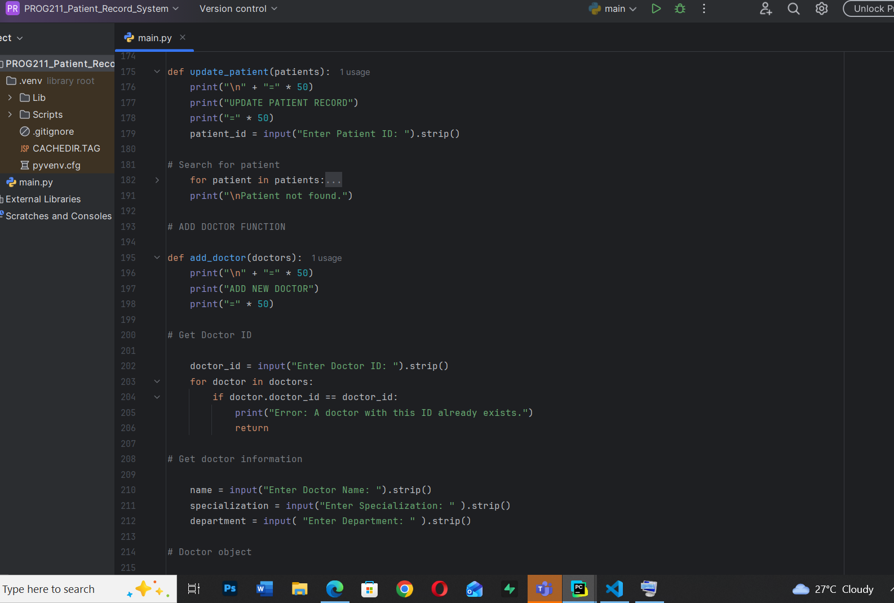

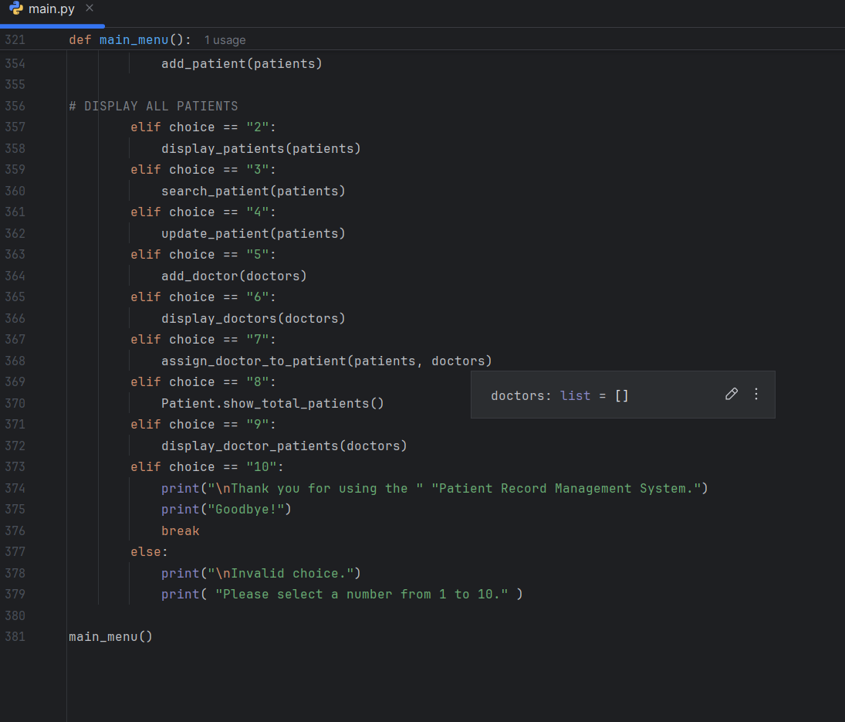

Appendix D Example Log Entries
The following examples show fictional program interactions that can be reproduced in Pycharm.
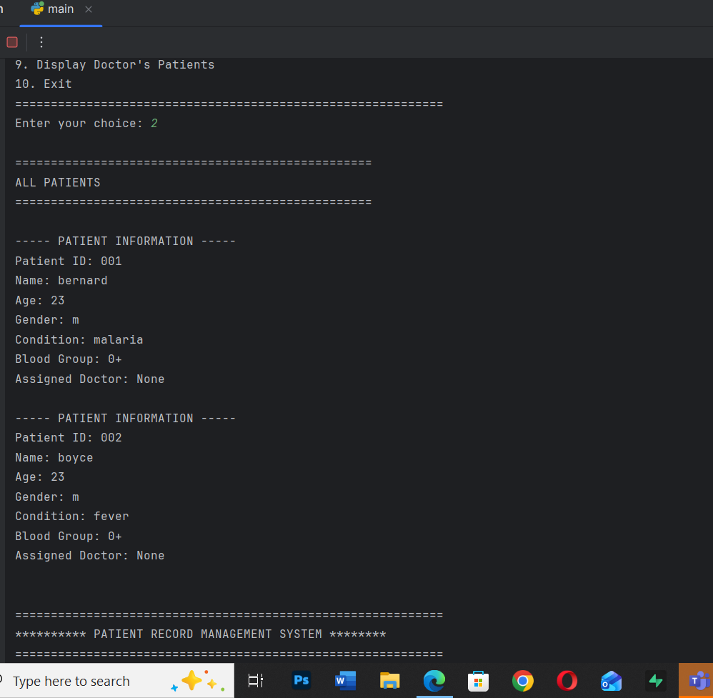

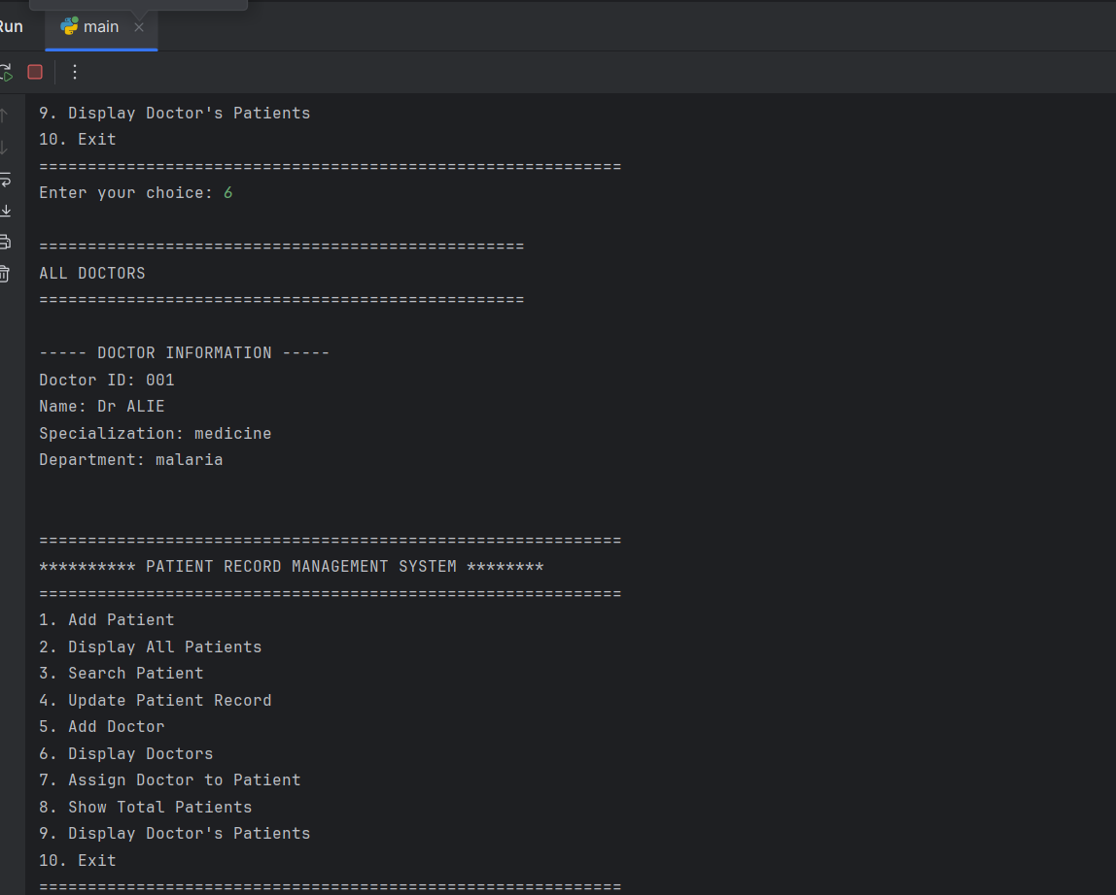

Appendix E System Testing Output
The system testing output should be supported with screenshots captured from the Pycharm Run winow. Recommended screenshots include the main menu, patient registration, patient display, patient search, patient update, doctor registration, doctor assignment, total patient count, and display of a doctor’s assigned patients. These screenshots provide visual evidence that the program was executed and tested.

References
PROG211 Object-Oriented Programming 1 Assignment Brief. Course assignment document supplied for the project.
Python Software Foundation. Python Documentation. Documentation classes, functions, methods, and built-in data structure.

